Assignment 2- Case Study

Stage 3 Lab Activities

SmartCare Domain Modelling
AI OFF -> AI ON -> COMPARE -> VERIFY | 1 hour

A - Requirements Review
- To find domain concepts, highlight nouns, verbs, and business rules from the SmartCare v0.2 criteria:
+) Key Nouns (Potential Classes):
- Patient --> mentioned in FR-01, FR-02, FR-03, FR-09, FR-10, FR-12
- Practitioner --> mentioned in FR-03, FR-04, FR-06, FR-10, FR-12
- Appointment --> mentioned in FR-03, FR-04, FR-05, FR-07, FR-08, FR-09, FR-10
- User --> mentioned in FR-12, NFR-06
- Status --> mentioned in FR-03, FR-05, FR-07
- Time/Slot --> mentioned in FR-03, FR-04, FR-06, FR-08
- History --> mentioned in FR-09
- Report --> mentioned in FR-10
- Cancellation --> mentioned in FR-07
- Error / Validation --> mentioned in FR-11

+) Key Verbs (Potential Operations):
- create - Create patient (FR-01), create appointment (FR-03)
- search - Search patient by name/ID (FR-02)
- book - Book appointment (FR-03)
- prevent - Prevent overlapping bookings (FR-04)
- manage/transition - Manage status changes (FR-05)
- display - Display availability (FR-06)
- cancel - Cancel appointment (FR-07)
- reschedule - Move appointment (FR-08)
- maintain - Maintain immutable history (FR-09)
- generate - Generate reports (FR-10)
+) Key Business Rules:
- BR-1: No practitioner can have overlapping appointments on same day (FR-04)
- BR-2: Appointments transition through states: Pending → Confirmed → Completed/Cancelled (FR-05)
- BR-3: Cancellation reason and timestamp must be recorded (FR-07)
- BR-4: Only authorized roles can perform actions (FR-12)

B - Candidate Classes
- Record candidate concepts, supporting requirements, state and behaviors:
Candidate | Class? | Reason | Evidence
Patient | ✓ YES | Core domain entity. Represents clinic patient with identity, demographics, contact info. Essential for appointment linkage and search. | FR-01 (registration), FR-02 (search), FR-03 (booking requires patient)
Practitioner | ✓ YES | Core domain entity. Represents clinic staff with schedule and availability. Central to appointment assignment and conflict detection. | FR-03 (appointment with practitioner), FR-04 (practitioner availability), FR-06 (practitioner calendar)
Appointment | ✓ YES | Core domain entity. Represents booking linking patient + practitioner + time. Implements all booking logic. | FR-03 through FR-09 (entire appointment workflow)
User | ✓ YES | Essential for access control. Represents authenticated system user with role and permissions. | FR-12 (authentication, role-based access), NFR-06 (audit logging by user)
AppointmentHistory | ✓ YES | Required by FR-09 for immutable change log. Tracks all appointment modifications with timestamps. Enables audit trail and compliance. | FR-09 (maintain complete, immutable history), NFR-06 (audit logging)
AppointmentReport | ✓ YES | Required by FR-10 for operational reporting. Generates utilization, cancellation rates, booking patterns. Essential for manager role. | FR-10 (operational reporting), FR-12 (manager views reports)
SecurityManager | ✓ YES | Required by NFR-06 for encryption, authentication, audit logging. Centralized security concerns. | NFR-06 (AES-256 encryption, TLS 1.3, key management, audit logging)
Clinic | ✗ NO (v0.2) | Out of scope. v0.2 assumes single clinic. Multi-location support deferred to v0.3+. No FR or NFR mentions clinic as manageable entity. | Case study: "small clinic"; no FR-X requires multi-location support
TimeSlot | ✗ NO (v0.2) | Deferred. Would be needed if appointment durations vary by practitioner/service, but open question remains unresolved. For v0.2, assume fixed 30-minute slots (attribute on Appointment). | FR-04 requires overlap detection but duration not yet confirmed; assume constant 30 min
AppointmentStatus | ✗ NO | Enum attribute, not class. Status transitions (Pending → Confirmed →Completed/Cancelled) implemented as Enum on Appointment. Creating separate class over-engineers v0.2. | FR-05 mentions status but doesn't require separate class; insufficient for v0.2
CancellationReason | ✗ NO | Attribute, not class. FR-07 specifies dropdown list of reasons stored as string attribute on Appointment. No logic justifies separate class. | FR-07: "select cancellation reason (Patient Request, No-Show, Doctor Decision, Other)" – not a class

C - CRC Cards
- Create CRC cards for Patient, Practitioner and Appointment:
+) Patient CRC Card: --> Role: The patient serves as both the demographic container and the identification holder. owns the entire patient lifecycle, including registration and lookup.
Responsibilities | Collaborators
Store patient identity data - patient_id, name, DOB, phone, email, medical_notes | Appointment - Patient has many appointments over time
Generate/assign unique patient ID automatically on registration | User - Receptionist (user) creates patient records
Validate patient data - Ensure non-empty name, valid email format, valid DOB (not future) | SecurityManager - Encrypt phone, email, DOB before storage
Enable patient lookup - Search by full name or patient ID with 2-second response (FR-02, NFR-04) | AppointmentHistory - Track patient's appointment change history
Maintain patient profile immutability - Once created, patient demographics don't change (or change is logged) | NONE

+) Practitioner CRC Card: --> Role: The practitioner's role is to possess resources. owns scheduling availability and uses availability checks to stop overbooking.
Responsibilities | Collaborators
Store practitioner identity - practitioner_id, name, specialty | Appointment - Practitioner has many appointments (can see multiple patients/day)
Manage working hours - Define standard clinic hours (8 AM-6 PM Mon-Fri) per practitioner | AppointmentReport - Report generates utilization % (booked slots / available slots)
Define blocked time - Add lunch breaks, admin time, days off to block practitioner from bookings | User - Practitioner (user) views own schedule (FR-12)
Display available time slots - Return free slots for 4-week window for booking interface (FR-06) | SecurityManager - Audit log practitioner actions (schedule changes, availability updates)
Check availability - Query whether practitioner is free at specific time (used by Appointment.check_overlap()) | NONE

+) Appointment CRC Card: --> Role: The booking process is coordinated by the appointment. owns the business logic (cancellation rules, status validation, overlap detection).
Responsibilities | Collaborators
Store appointment data - appointment_id, patient_id, practitioner_id, time, status, duration (30 min fixed) | Patient - Each appointment belongs to exactly patient
Implement business rule BR-1 - Prevent overlapping time slots for same practitioner on same day (FR-04) | Practitioner - Each appointment is with exactly 1 practitioner
Call check_overlap() at booking time - Query Practitioner.check_availability() before creating appointment | AppointmentHistory - Log every change (creation, status, cancellation, reschedule) with timestamp
Manage appointment lifecycle - Transition status: Pending→Confirmed→Completed or Cancelled (FR-05, BR-2) | User - Receptionist/Practitioner perform actions; audit logged
Record cancellation details - Store cancellation_reason and cancellation_timestamp (FR-07) | SecurityManager - Audit log all appointment actions

D - UML Model
- Draw classes, attributes, operations, associations and multiplicities.
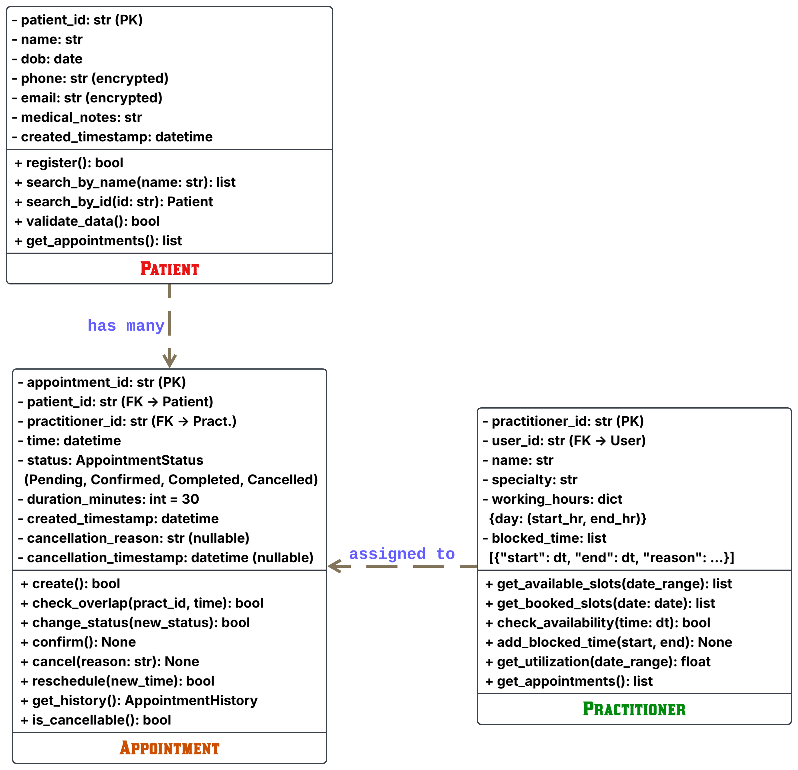

- Relationships The diagram illustrates the interactions among these entities using directional lines:
- Patient to Appointment ("has many"): Each Patient may have multiple Appointments over time. The association is established through the patient_id foreign key.
- Practitioner to Appointment ("assigned to"): A single Practitioner can be assigned to multiple Appointments. The Practitioner is linked to the Appointment via the practitioner_id foreign key.

E - AI Design Review
- Ask AI to suggest classes and relationships using only confirmed requirements; require supporting requirement IDs.
Class | Requirement Evidence | Why Essential
Patient | FR-01 (registration), FR-02 (search) | Represents clinic patient. Enables appointment linkage and patient lookup - core clinic operation.
Practitioner | FR-03 (appointment with), FR-04 (conflict), FR-06 (calendar) | Represents clinic staff/resource. Owns scheduling and availability - central to overbooking prevention.
Appointment | FR-03→FR-09 (entire workflow) | Central entity binding Patient + Practitioner + Time. Implements booking logic, conflict detection, lifecycle management.
User | FR-12 (authentication, RBAC) | Guards access control. Every action audited to User. Essential for compliance and permissions.
AppointmentHistory | FR-09 (immutable history), NFR-06 (audit logging) | Required by compliance requirements. Enables audit trail and prevents tampering with records.
AppointmentReport | FR-10 (operational reporting), FR-12 (manager role) | Manager stakeholder explicitly needs utilization/cancellation metrics. Separate class enables independent reporting logic.
SecurityManager | NFR-06 (encryption, TLS, key mgmt, audit) | Cross-cutting security concerns. Centralizes encryption, authentication, audit logging across system.

- Essential Connections & Quantity:
+) Patient 1:* Appointment*
- One patient can have multiple appointments over time (revisits clinic)
- Minimum: 0 (patient created but no appointments yet - OK)
- Maximum: unlimited (patient can visit many times)
- Evidence: FR-09 (appointment history implies multiple per patient), FR-10 (reporting per patient), clinic domain knowledge (patients revisit)
+) Practitioner 1: *Appointment*
- One practitioner can see multiple patients per day (clinic operations)
- Minimum: 0 (practitioner hired but no appointments scheduled)
- Evidence: FR-04 suggests that practitioners manage several appointments each day, while FR-06 indicates that the availability calendar displays numerous time slots.
+) User 1:*Practitioner* (every practitioner possesses a single user account for access)
- Relationship identified during design: Practitioner.user_id → User
- Evidence: FR-12 mandates authentication by practitioners; practitioners must log in to access their schedule.
+) Appointment: *Patient* (every appointment is assigned to one specific patient)
*Practitioner* (each appointment occurs with one specific practitioner)
- Evidence: FR-03 states "choosing a patient, choosing a practitioner" (singular), v0.2 scope: no multiple practitioners or group appointments.

F - Compare and Decide
- Record at least one accepted, modified and rejected AI suggestion.
AI Suggestion | Decision | Justification
PatientManager | REJECT | Considered an architectural anti-pattern since the Patient class directly encapsulates its own operations, making an external manager redundant.
PractitionerManager | REJECT | Adds unnecessary indirection because Practitioner already cohesively handles both its profile data and availability logic.
AppointmentManager | MODIFY | Current v0.2 booking workflows are simple. AI noted that complex multi-step processes or notifications should be introduced.
ClinicController | REJECT | Violates architectural layering principles by introducing application controller logic into the core domain model.
NotificationManager | REJECT | Out of scope for release v0.2; explicitly postponed to version 0.3+ during Stage 2 planning.
ScheduleEngine | ACCEPT | Fixed 30-minute time slots keep v0.2 scheduling straightforward

All proposed AI suggestions were vetted against evidence; one was accepted directly into release v0.2, and one was adapted for potential future adoption using clear reconsideration criteria.

G - Python Skeletons (3 separate .py files)
- Create simple Patient, Practitioner and Appointment class skeletons.

H - Consistency Check
- Check model-code consistency; do not implement full behaviour yet.
Class | UML Attributes | Python Attributes | ✓ Match? | UML Operations | Python Methods | ✓ Match?
Patient | patient_id, name, dob, phone, email, medical_notes | ✓ All present | ✓ YES | register, search_by_name, search_by_id, validate_data, get_appointments | ✓ All present | ✓ YES
Practitioner | practitioner_id, user_id, name, specialty, working_hours, blocked_time | ✓ All present | ✓ YES | get_available_slots, get_booked_slots, check_availability, add_blocked_time, get_utilization, get_appointments | ✓ All present | ✓ YES
Appointment | appointment_id, patient_id, practitioner_id, time, status, duration_minutes, created_timestamp, cancellation_reason, cancellation_timestamp | ✓ All present | ✓ YES | create, check_overlap, change_status, confirm, cancel, reschedule, get_history, is_cancellable | ✓ All present | ✓ YES

Reflection
- What modelling decision was hardest? Where did AI overdesign? What evidence supported your final choices?
The central challenge was determining where to draw the line between creating standalone classes and simply embedding attributes within existing models. The temptation to build helper classes like TimeSlot or AppointmentStatus was strong, as they offer an appealing sense of object-oriented purity, but creating them risked over-engineering ahead of actual need. Navigating this tension between theoretical "clean design" and the YAGNI principle demanded strict discipline.
This disciplined approach was immediately put to the test when the AI recommended six separate manager and controller classes, such as PatientManager and ScheduleEngine. Although these abstractions seemed sophisticated, the AI justified them using generic industry best practices rather than the explicit requirements defined for v0.2. Ultimately, the AI favored enterprise-level abstractions over appropriate domain simplicity.
Grounded in explicit clinic requirements, this lean, traceable, and implementation-ready model features 7 core classes. visualized in UML, AI-reviewed using evidence-based decisions, and verified via .py skeletons.

